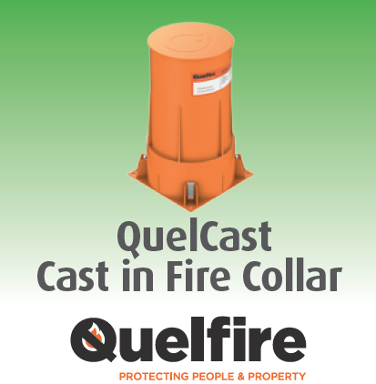

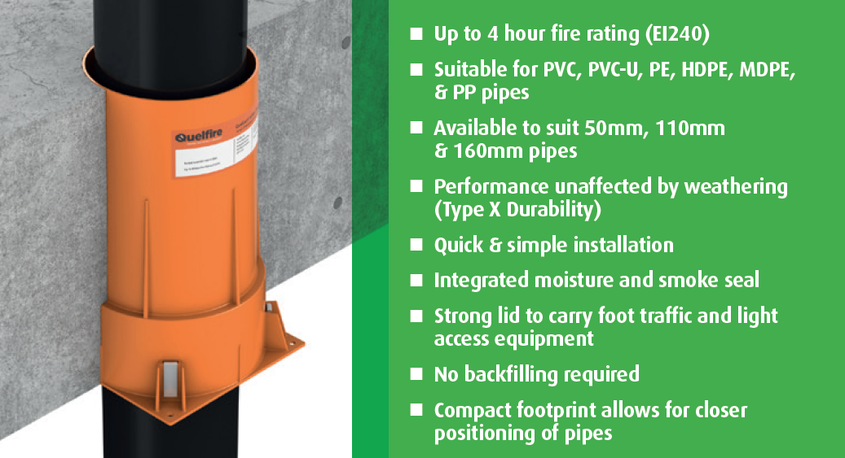

Description
Quelcast Fire Collars are constructed from a robust polypropylene material and contain a high performance intumescent material which reacts under the influence of heat. This will exert pressure on the pipe as it softens, to form a carbonaceous char which provides an effective insulation plug thus preventing smoke and fire passing through to the adjoining compartment.
Applications
Hic The QuelCast Fire Collar has been designed at 250mm high to meet the requirements of most applications. The Collar however can be cut down to suit up to a 150mm deep floor slab.
For the QuelCast 50 Fire Collar, the space between the pipe and the outer casing of the Collar should be backfilled with mineral wool from the rubber smoke seal to the top of the floor slab.

