Technical Data Sheet
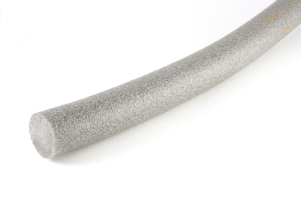
Joint Backer Rod
Polyethylene Foam Material
Description
Backer Rod is a non-absorbent,
compressible grey closed cell
polyethylene (P.E) foam
backup material.
Sizes Available in Grey
6mm x 2500m
10mm x 1150m
13mm x 750m
15mm x 550m
20mm x 350m
25mm x 200m
30mm x 160m
40mm x 270m
50mm x 180m
Product Specification
Box quantity – 1 Roll
Boxes / Pallet – 12
Storage
Store in original container in cool dry conditions, away from direct sunlight.
Shelf Life
Storage life in 12 months in tightly sealed, undamaged containers.
Health & Safety
Non-Hazardous

Benefits
- Quick and easy to apply.
- Reduces sealant usage.
- Improves sealant performance
by obtaining easily the correct
joint dimensions.
- Flexible; won’t bubble or blister.
Recommended for
- Reducing the depth or joints in
construction / glazing use.
- Creating a backstop to allow
proper sealant tooling.
For technical advice call
- 08450 505 986
Or email
- info@completeconstructionproducts

