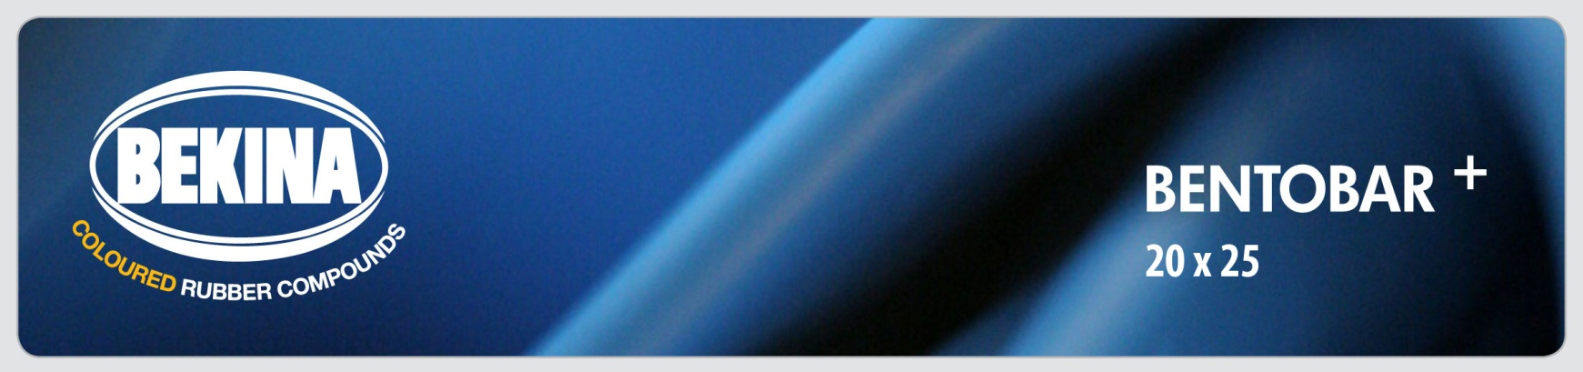
TECHNICAL DATA SHEET (TDS)

Hydrophilic swelling tape made of sodium bentonite and butyl rubber for
preventive sealing of working joints and as a system component for bentonite mats

USE
BENTOBAR+ is developed for preventive sealing of working joints against water in concrete and reinforced concrete construction and as a system component for bentonite mats.

Description
- BENTOBAR+ is made of high quality butyl rubber and sodium bentonite.
- It is available in different sizes and lengths. Standard colors are black and green, but BENTOBAR+ can also be supplied in other colors for larger quantities. A salt variant is available in red.
- In contact with water, BENTOBAR+ increases its volume as much as 240% of its original state. For detailed swell test results, we refer to the MFPA certificate, which is available on request

APPLICATION
- Place BENTOBAR+ on a smooth and dust free surface (concrete).
- Do not install BENTOBAR+ during heavy rainfall, as it may result in swelling before the concrete has been poured on this strip. Avoid all contact with water before concreting.
- BENTOBAR+ is laid between the inside and outside reinforcement.
- Respect a minimum concrete cover of 7-8 cm concrete on each side.
- Apply an overlap of 5 to 10 cm at the ends of the strip; press this overlap firmly against each other.
- BENTOBAR+ can be fixed by gunnailing. For vertical applications, we recommend the use of a wire mesh which is applied over the bentonite strip. Mesh and tape are then fixed also by gunnailing. For detailed
information on this mesh, kindly contact our technical department.
- Tapes that are damaged; already swollen, or whose geometry has been changed may not be installed.
- Protect BENTOBAR+ from moisture and frost when stored.
- In salt water environment or in contact with polluted water, we recommend BENTOBAR+ Salt (See separate TDS).

TECHNICAL DATA
Property | Value | Documented by
Swelling capacity in contact with water | typical 240% | MFPA Leipzig
Density | 1,43 g/cm3 | MFPA Leipzig
Weight | Approximately 0,65 kg/m | MFPA Leipzig
Swelling pressure if swelling is prevented | Approximately 1,8 N/mm2 | MFPA Leipzig
Resistance to hydrostatic pressure | Tested up to 4 bar | MFPA Leipzig
Bending radius on the corners | 50 mm | MFPA Leipzig
Installation temperature | 0°-50°C | MFPA Leipzig
Odour | none | MFPA Leipzig

Sizes and packaging
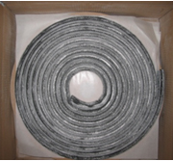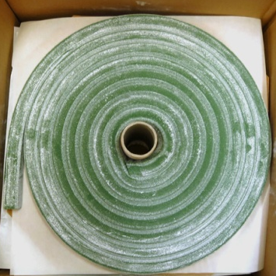

- Standard: 20 x 25 mm in lengths of 5 meter.
- Packed in cardboard box of 6 x 5 meter. Available in black or green.
- Other sizes (20 x 10 mm, 20 x 15 mm) other colors, or different packaging available on request.

Certificates
Detailed reports and certificates available on request at info@bekina-compounds.be

safety
For full information consult the Material Safety Data Sheet, which is available on request at info@bekina-compounds.be

